Welcome to our Orchar January update. We’ve had a busy month! The third Monday in January is often called Blue Monday – it is suggested that it’s the most depressing day of the year. Not for us though – we celebrated Betty’s 100th birthday in style. Most of her family were here, from home and abroad, and she was thrilled when she received a birthday card from the king and queen, and had a visit from the Lord Provost. We were entertained by Lynn McTaggart and there was a great atmosphere with everyone singing and dancing – including Betty! The following day, Betty and a few family members and other Orchar residents had another party at the Fairmuir Club. Everyone had a ball, especially Betty – and she said that turning 100 doesn’t hurt!

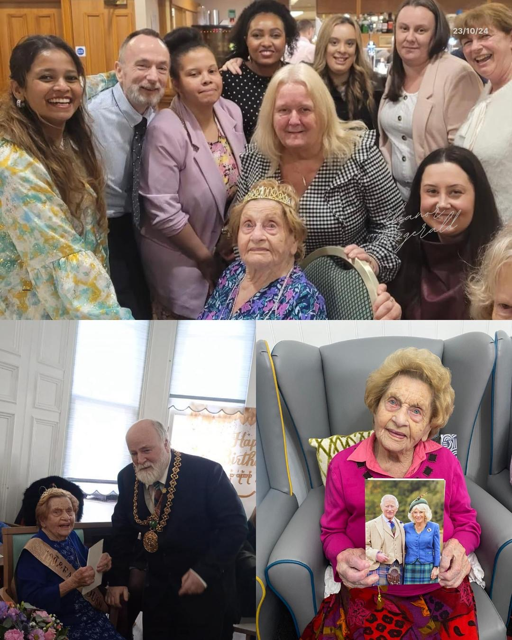

Most of our residents take part in our fun fitness sessions and have recently enjoyed learning to do Tai Chi as well as our usual seated exercises and “cycling”.

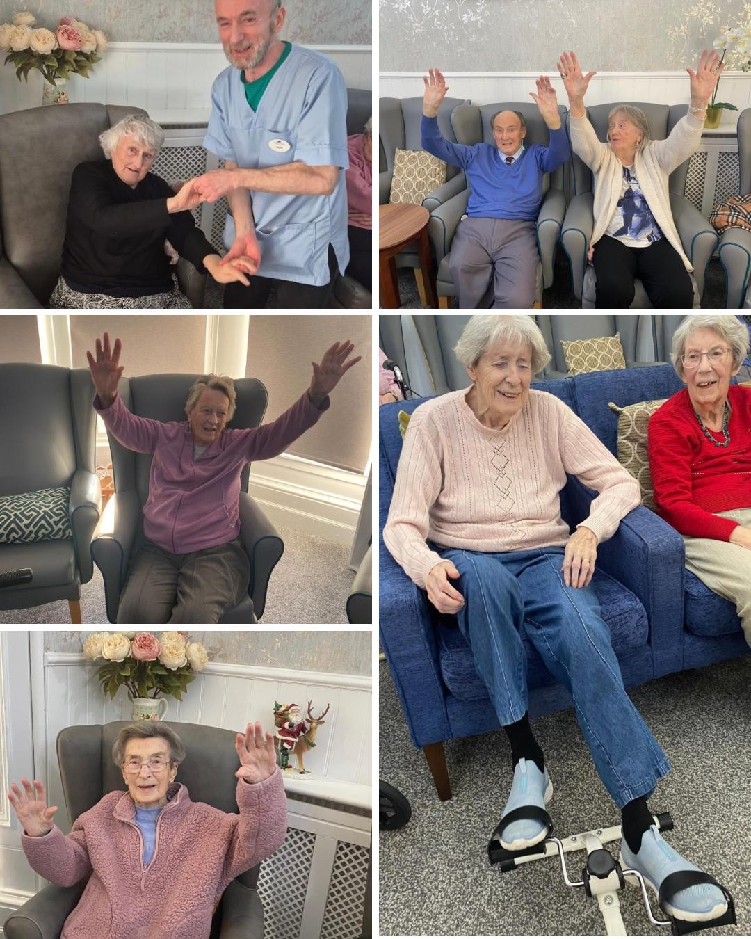

Josh came back to play the bagpipes and Mary had a Scottish afternoon to help us to celebrate Burns Day, and of course we had the traditional Burns Supper. Our chef Iain did a great job of addressing the haggis.

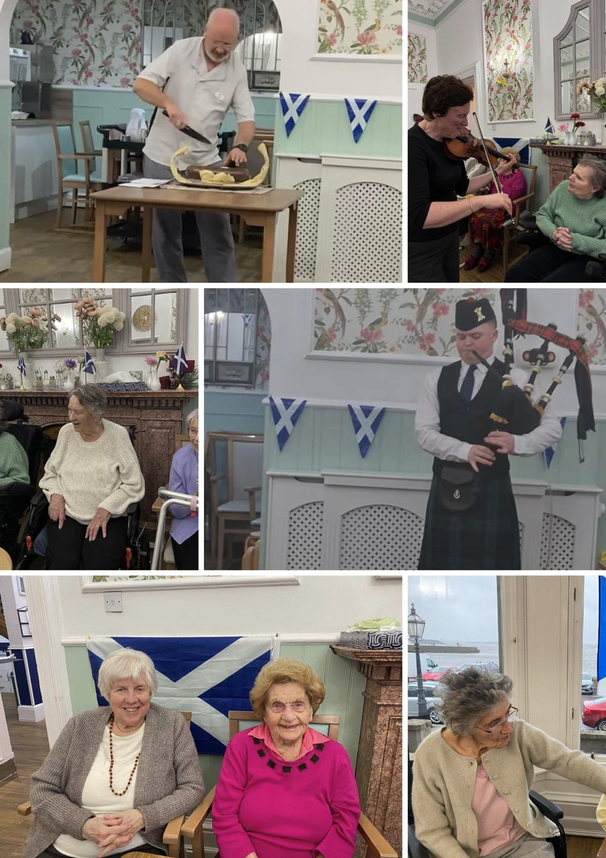

We like to celebrate other national events which are possibly less well-known too – we have some nice photos of the residents enjoying National Shortbread Day

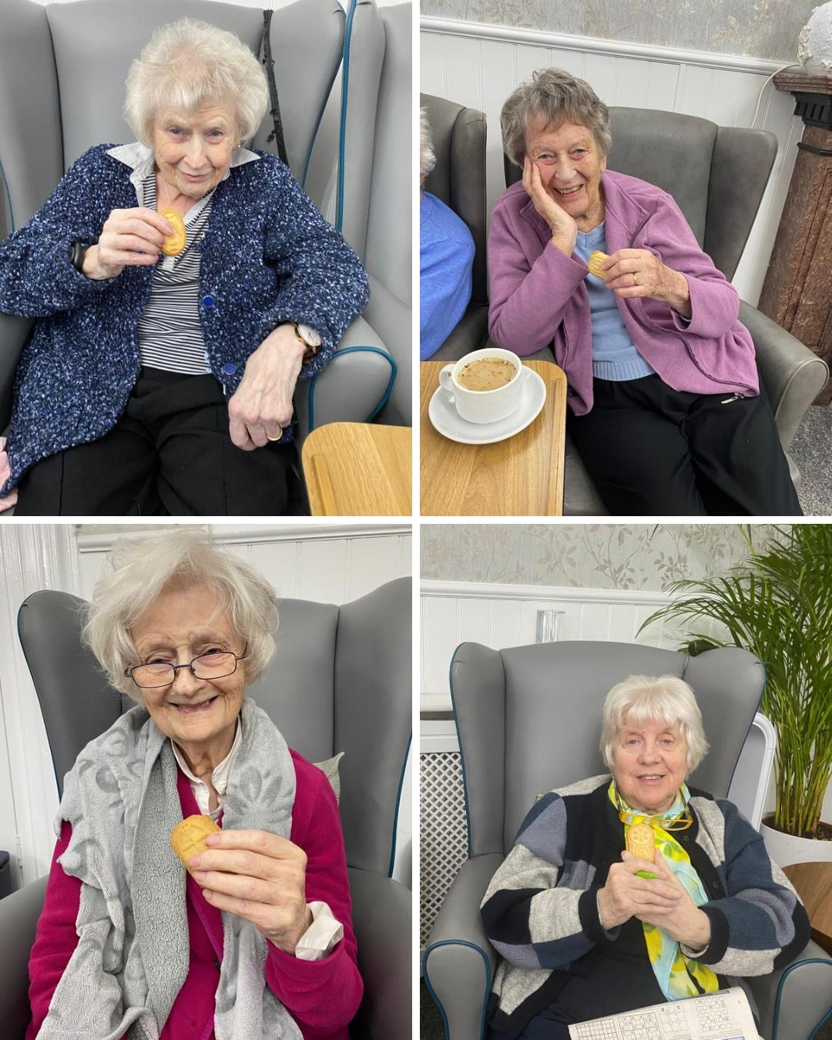

We’ve had a couple of baking sessions which some residents thoroughly enjoyed, and as always we’ve had our popular Music Therapy and Pet Therapy sessions.

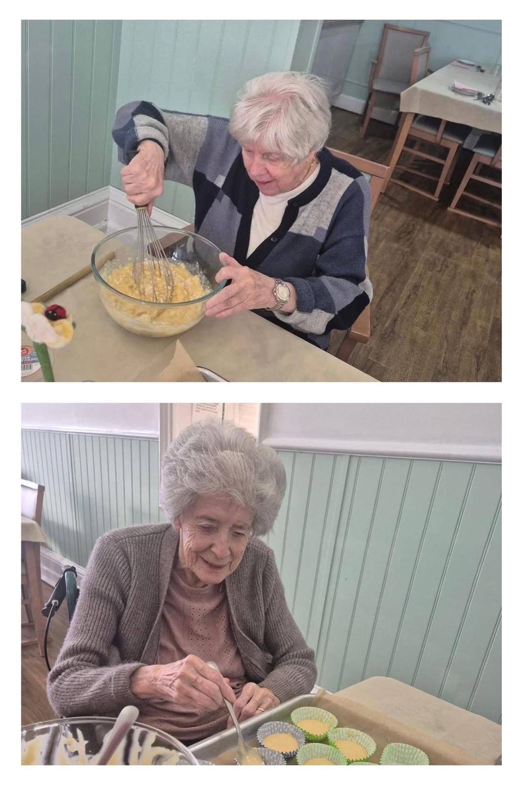

We look forward to having a Valentine’s Day celebration and a Cheese & Wine afternoon with entertainment from Johnny Mack, amongst other things.
Just a reminder that families are also welcome to come and have a meal with their loved ones – please let us know in advance if you’d like to join us.

We’ve had some excellent reviews from residents and their families so thank you very much for your lovely comments.

