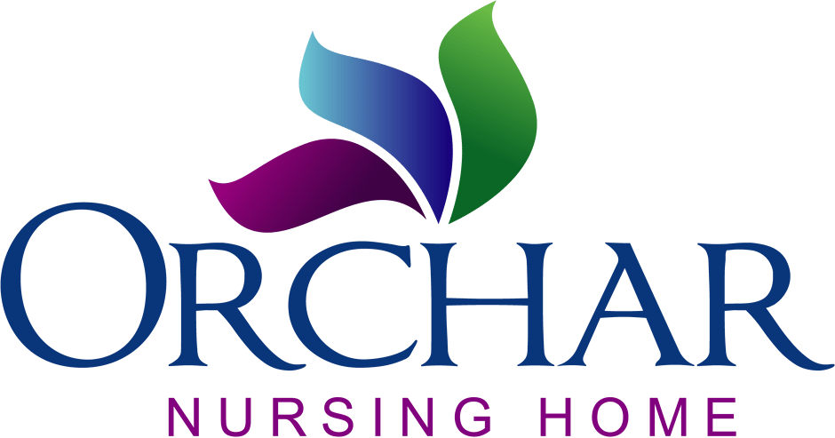

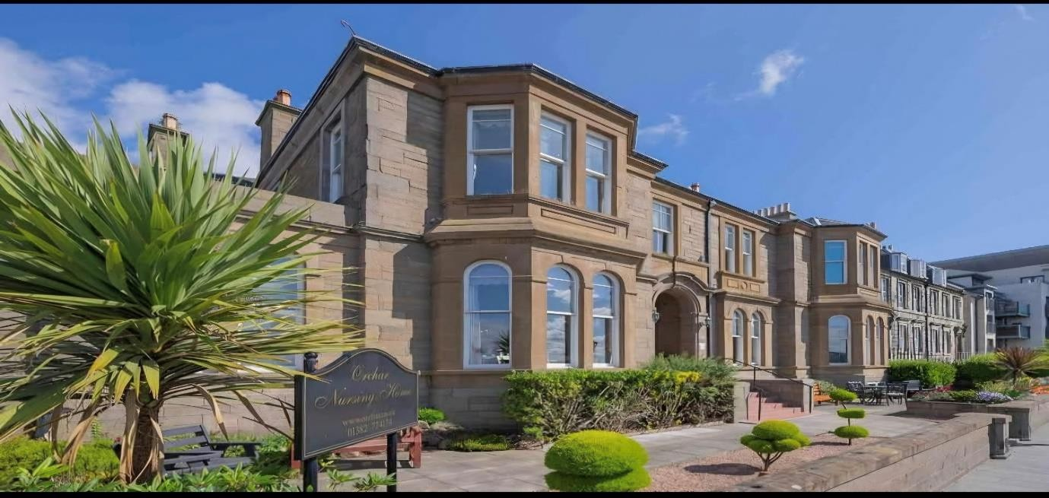

Orchar Nursing Home Newsletter for October/November, 2025

Welcome to the latest edition of our newsletter! We like to keep residents and families up to date with what’s been happening.

We had a “spooktacular” time at Halloween – staff and residents dressed up as witches, ghosts, monsters etc for our party, and everyone looked “fang-tastic”! The entertainment was provided by Paul Sullivan, and a great time was had by all.
Ahead of the party we decorated Halloween cakes and did some Halloween crafts – making ghosts, spiders, etc.

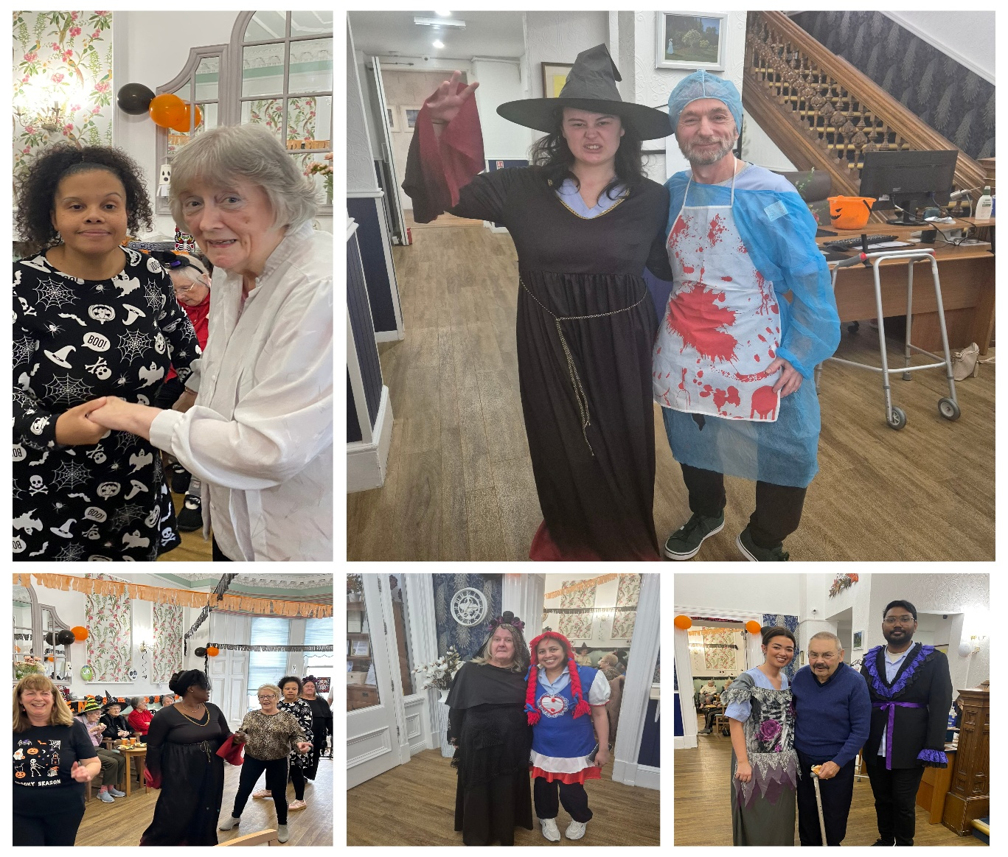

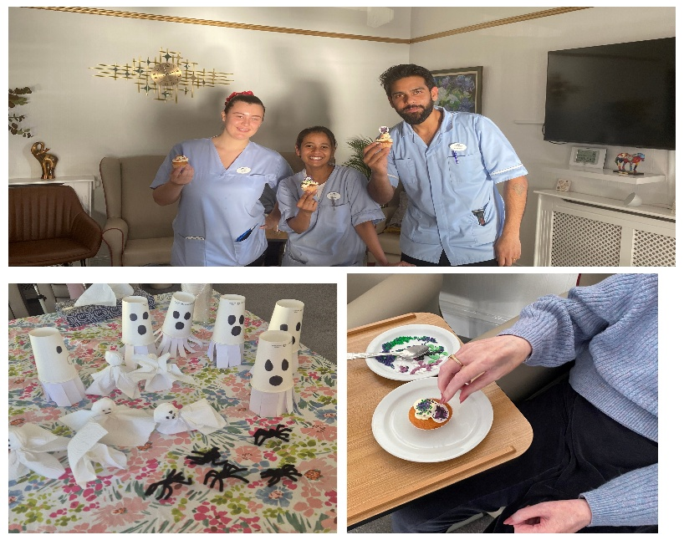

We’re so happy that Heart for Art has re-started – our regular attendees love going – they enjoy the chat and the delicious cakes as much as the art. Jean crocheted a blanket for the upcoming coffee morning, and Pat brought along 2 jigsaws. One of the volunteers said if everyone was like them, the world would be a better place!
At the beginning of October, we had a service of prayer for peace, along with people all around the world, and we were delighted to hear that a ceasefire was called not long afterwards.
We celebrated National Train Your Brain Day in a big way – with plenty brainteasers, riddles, quizzes and alphabet games.
Our quarterly Residents’ Meeting was well attended, with residents giving their opinions and points of view.
We always look forward to our Music Therapy and Pet Therapy sessions, and residents also enjoy our regular morning exercises and film afternoons with drinks and nibbles.

In November, as well as our regular games of bingo, quizzes, games and pamper sessions etc, we had a lovely Remembrance Service followed by a wartime singalong, a jazz afternoon featuring West coast jazz band Stone Combo, The Twa Grannies who led a lovely old-fashioned singalong, visits from the local nursery school and a lovely Scottish afternoon for St Andrews Day.

We’re now looking forward to all the Christmas entertainment – outings, parties, nursery and school pupil visits, carol services etc.
